Basics of Windows Server and Active Directory

Tasks

1. Install Windows Server on a virtual machine using VirtualBox or VMware and take a screenshot of the desktop after the installation completes.

ANS:

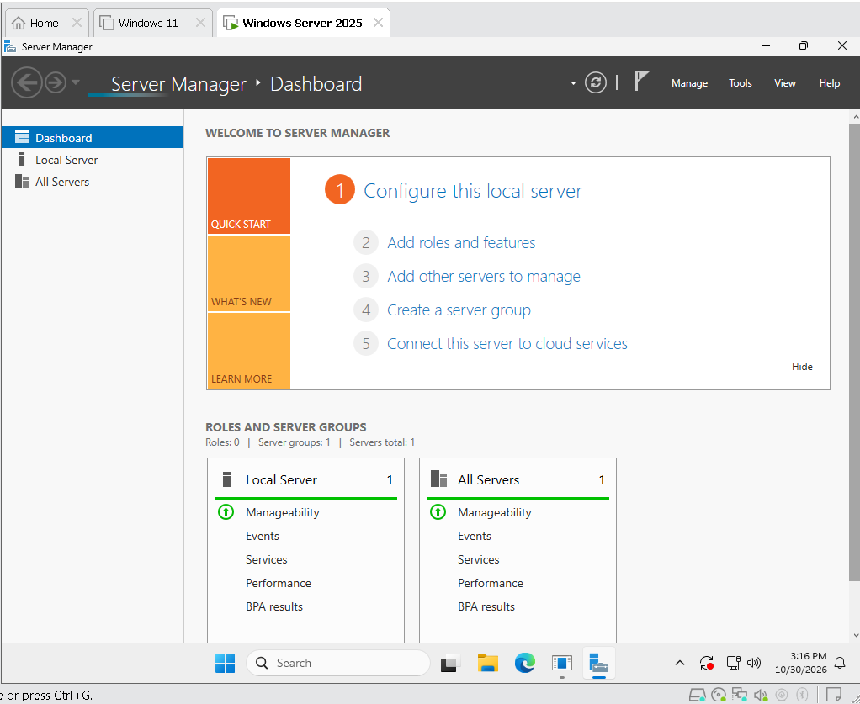

2. Open Server Manager and use the 'Add roles and features' wizard to install the Active Directory Domain Services (AD DS) role. Document each step with a short description and screenshot.

ANS:

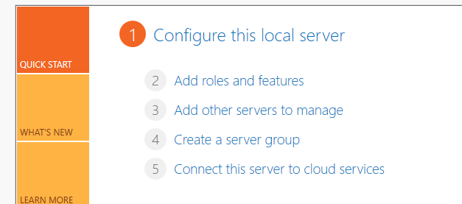

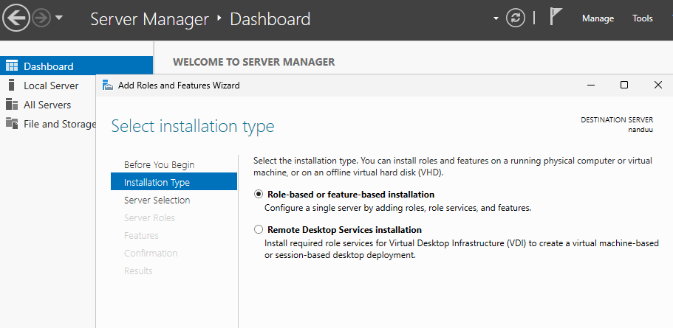

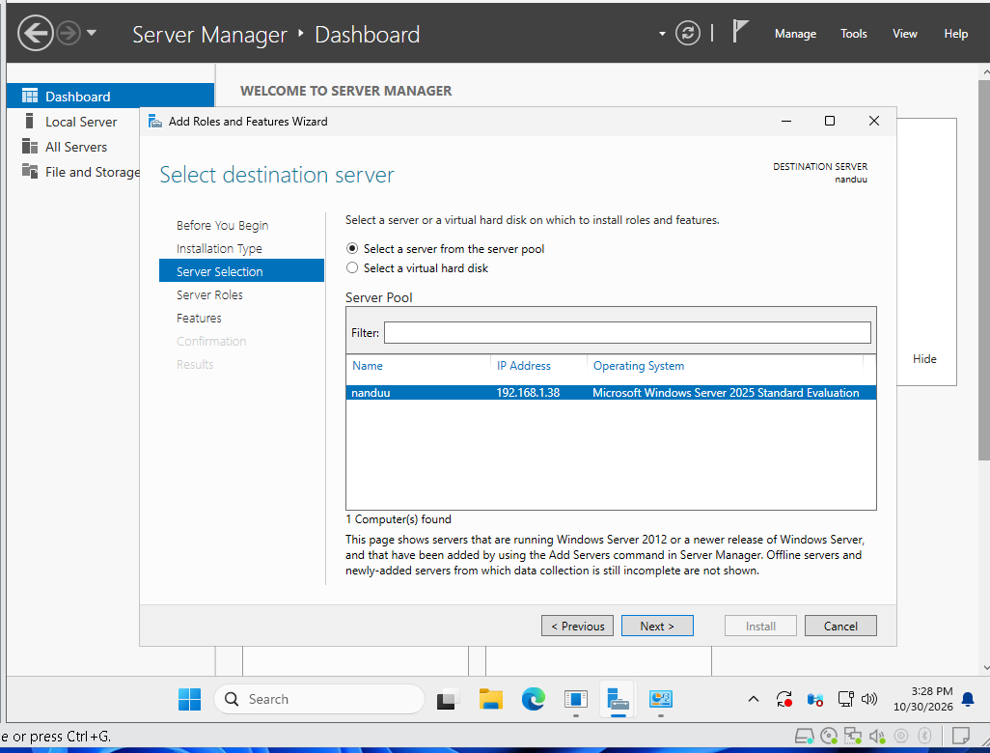

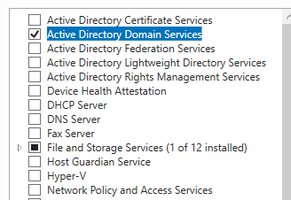

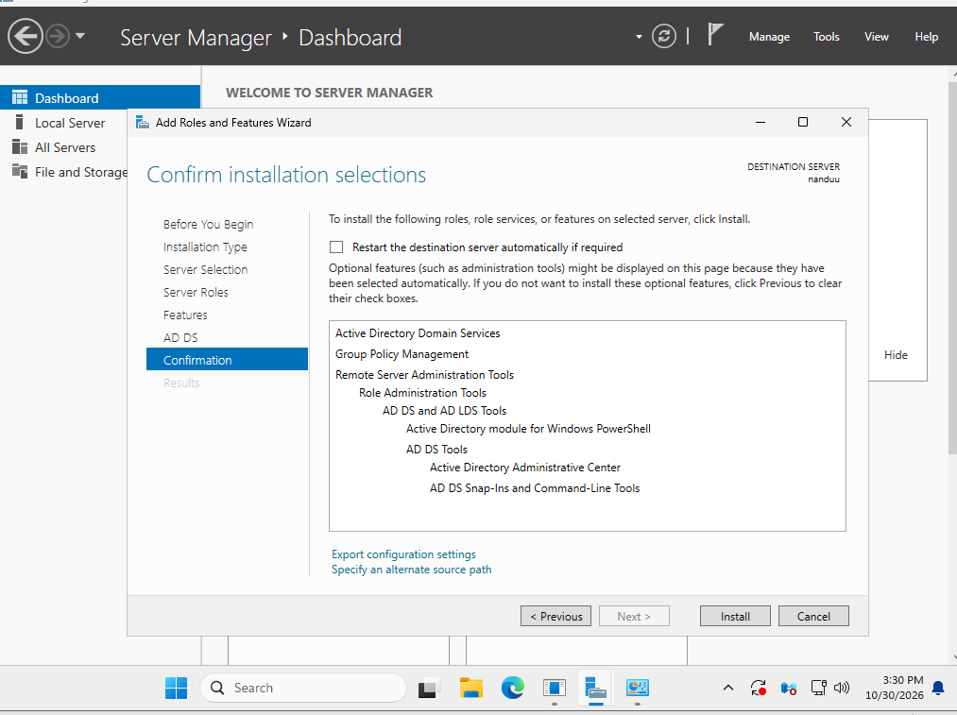

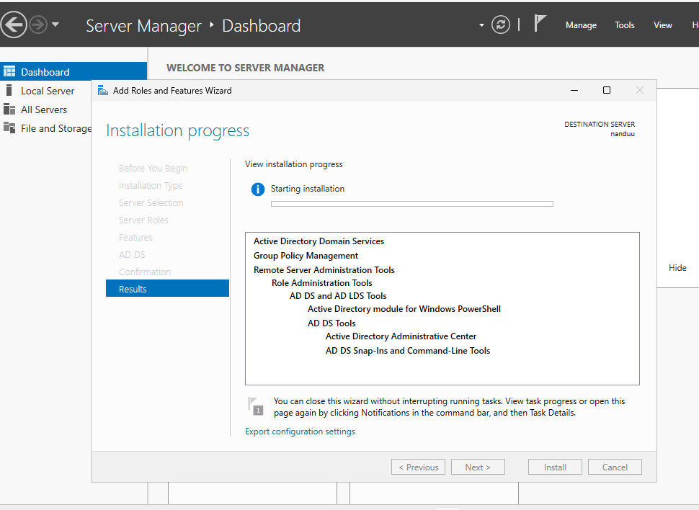

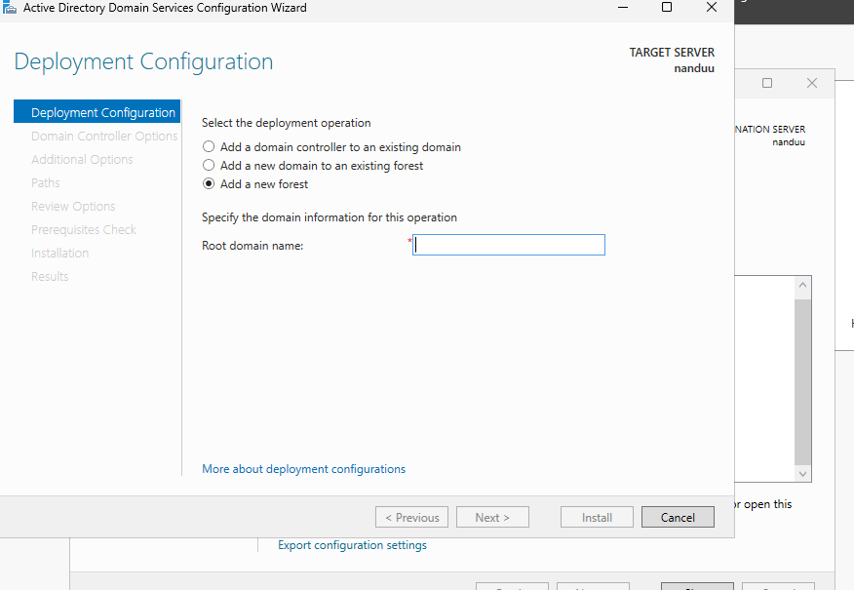



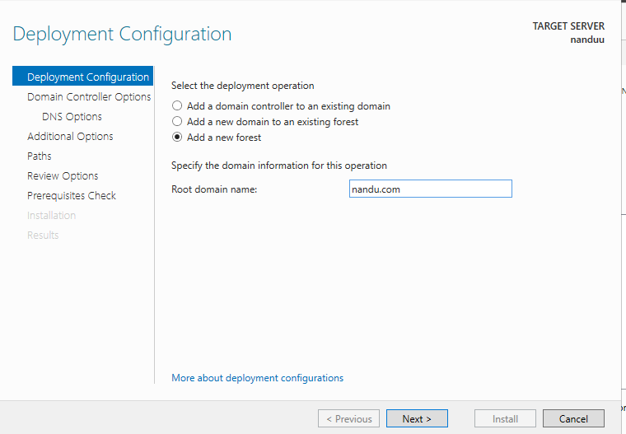

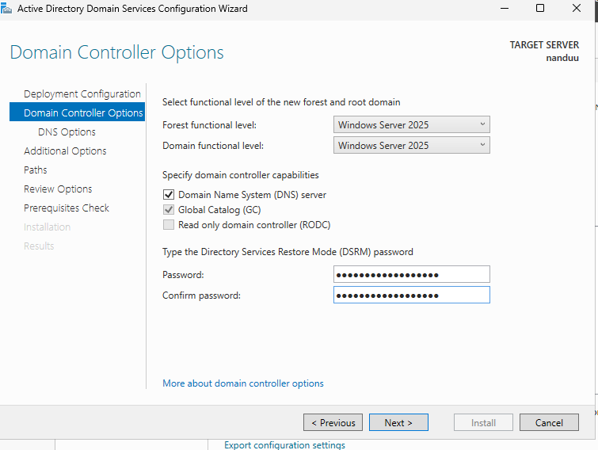

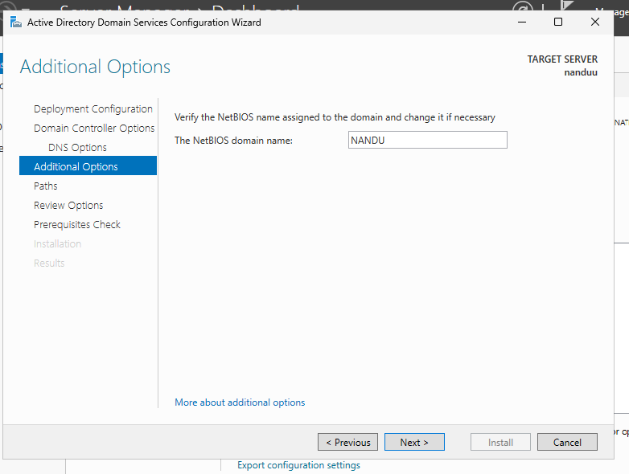

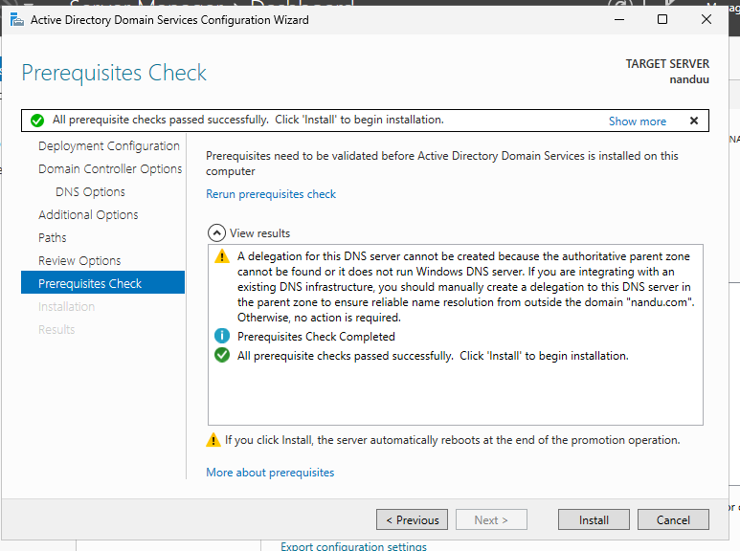

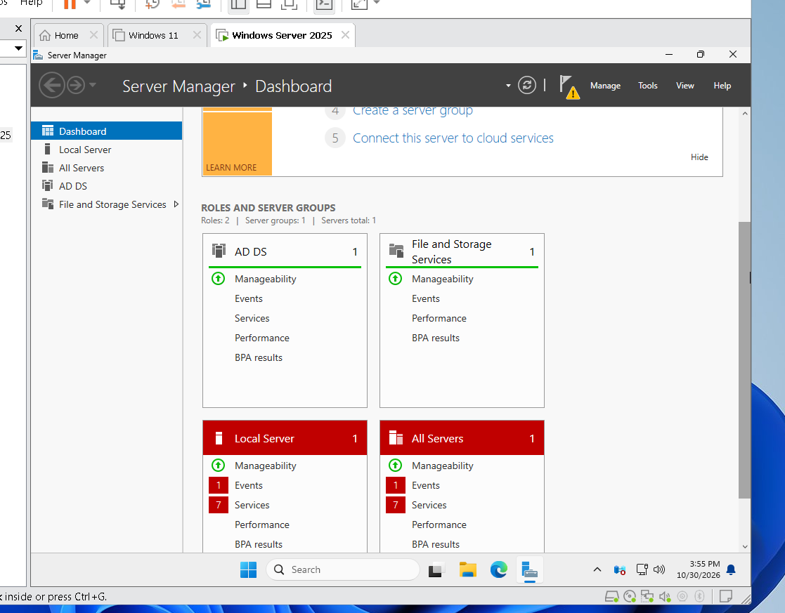



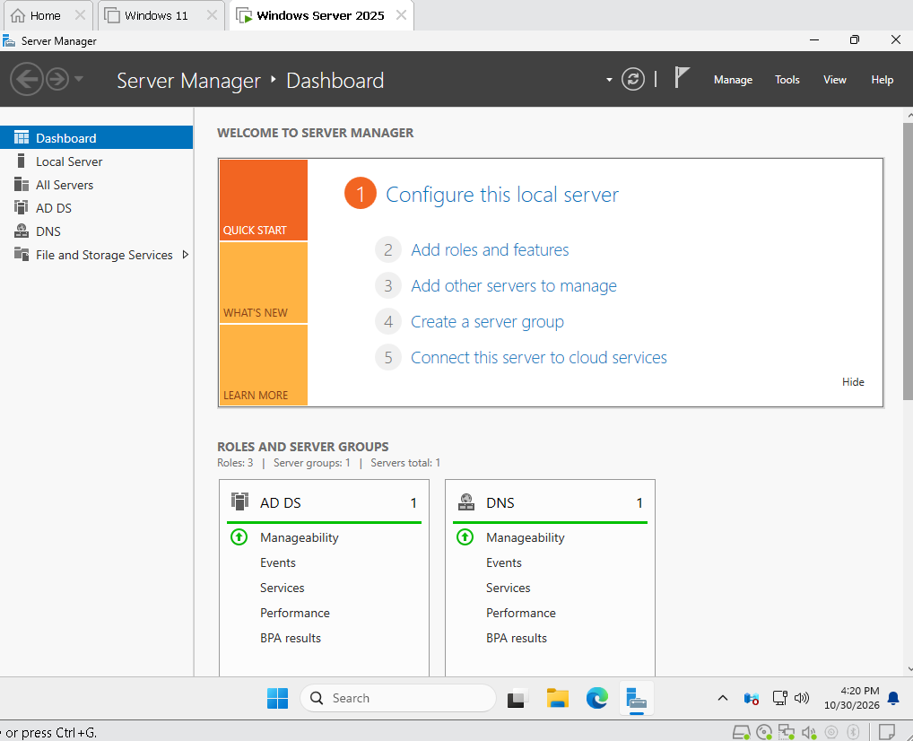

3. Promote your Windows Server to a Domain Controller by creating a new forest with a root domain name of your choice (e.g., mycollege.local). List the options you selected during the configuration.

ANS:

4. Create two new user accounts and one group in Active Directory Users and Computers. Assign both users to the group and describe how you did it. Use the 'Users' container and right-click options in ADUC.

ANS:

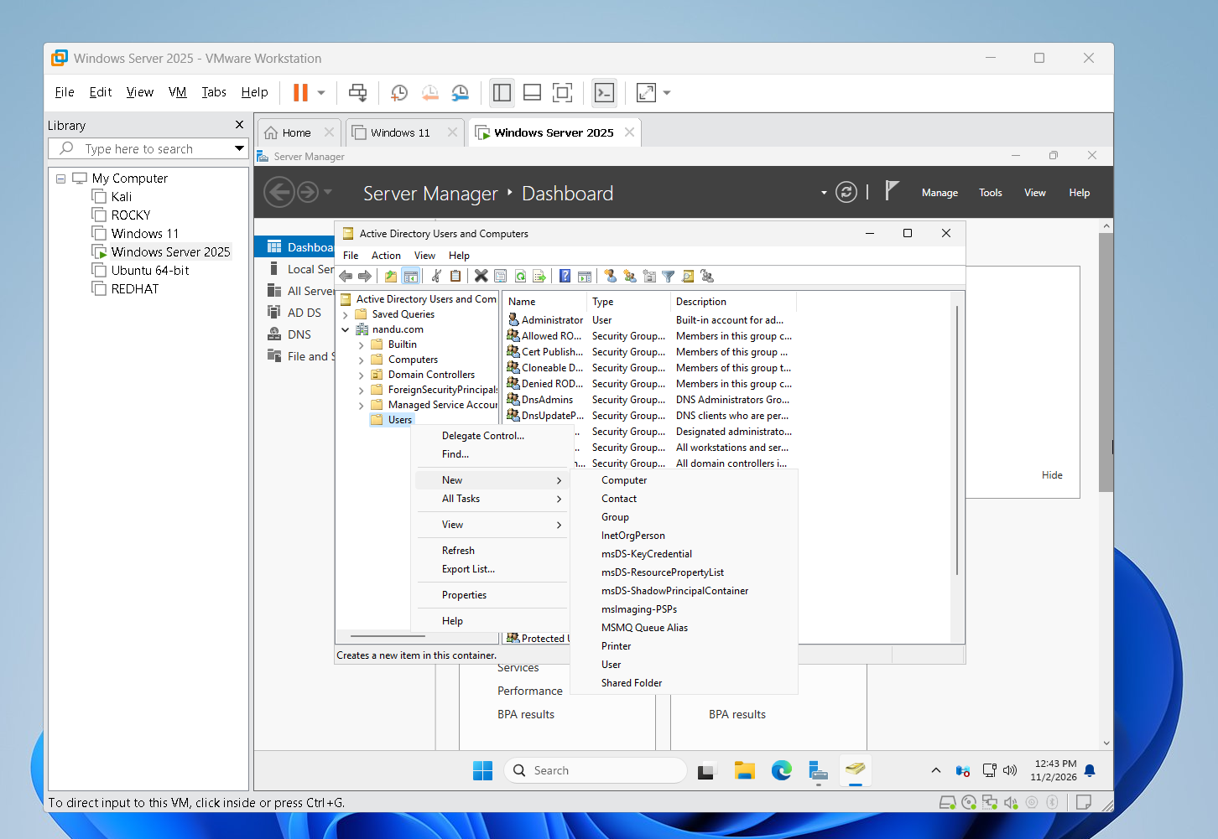

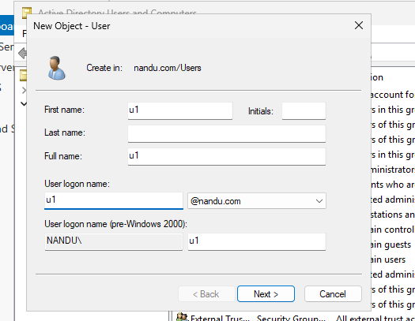

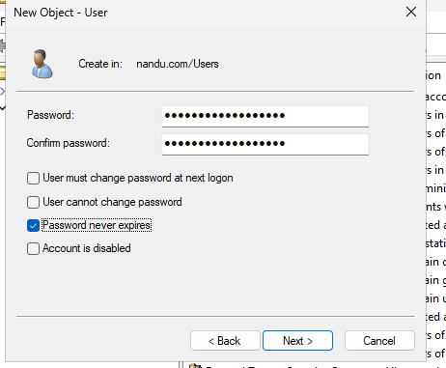

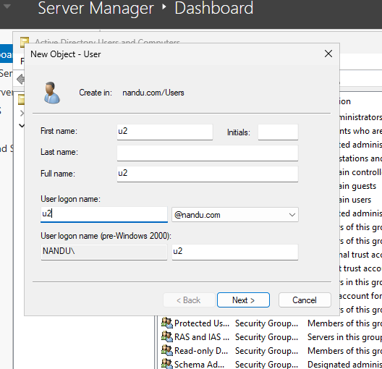

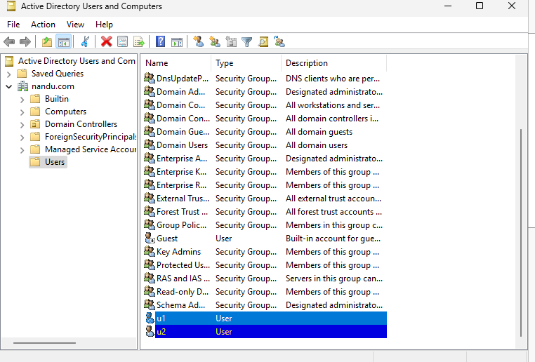

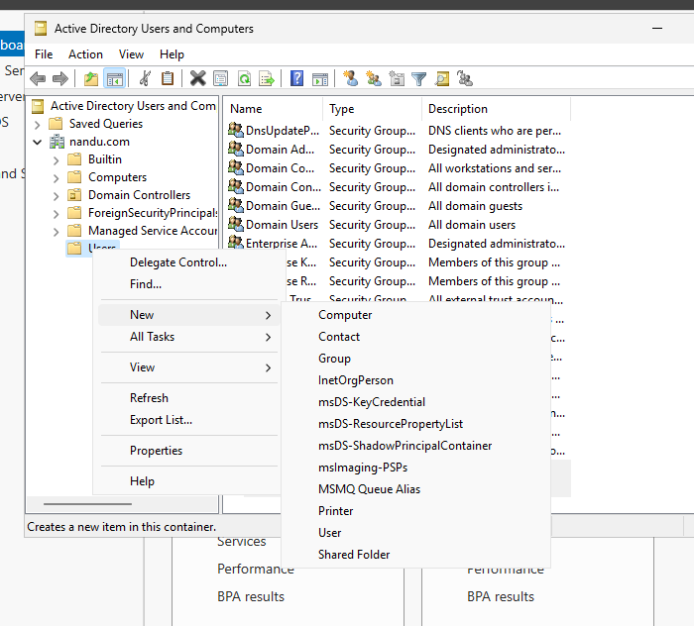

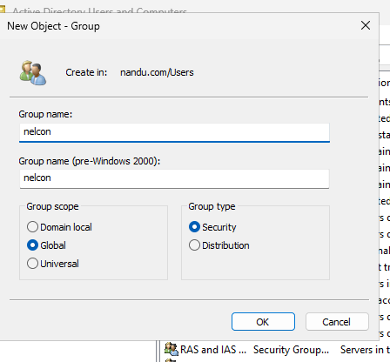
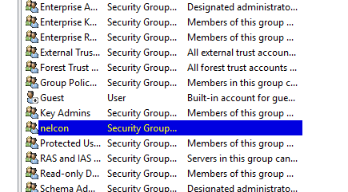

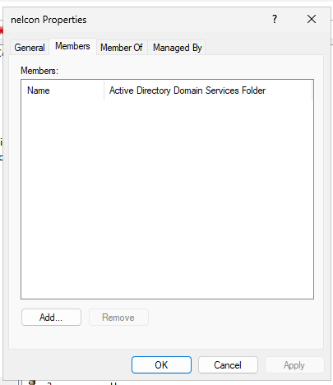

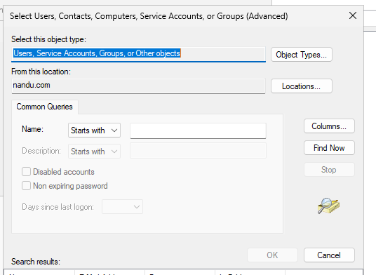

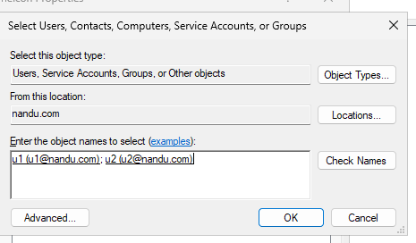

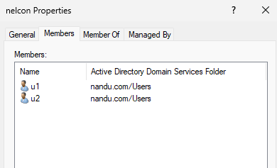

1. Open Server Manager → Tools → Active Directory Users and Computers (ADUC). Expand your domain and right-click the Users container.

2. Select New → User. Create two accounts named u1 and u2, set their passwords, and finish the wizard.

3. Right-click the Users container again and select New → Group. Create a group named nelcon, select Global scope and Security type.

4. Right-click the nelcon group → Properties → Members → Add. Enter u1 and u2, click Check Names → OK → Apply. Both users are now members of the group.

